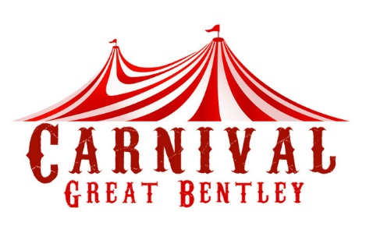

Great Bentley Carnival and Fete Association
Stall Pitch Booking Form

Date: Saturday 29th June 2024 Venue: Great Bentley Village Green

Name of Organisation
Contact Name
Address

Post Code
Phone Number
Email Address
Type of stall

Charity or Commercial

Stalls may be set up on the day from 8am and must be cleared away by 6pm
The day starts at 12.00 with a procession around the village. Roads will be closed prior to start time, so to be on the safe side please ensure you are set up by 11.00am
Parking will be available close to your stall. You will need to provide your own table/chairs/gazebo etc. and please don’t forget to bring a bag for your litter at the end of the day.

Stall Prices
Charities/Schools/Groups - 15ft wide plot = £30.00 & Double plot = £55.00 (This may be subject to change with prior agreement)
Commercial - Negotiated at % rate of day’s takings. To be paid on day.

Payment Methods
Cheque – payable to: Great Bentley Carnival and Fete Association
BACS – Sort code: 09-01-29 Account: 34978157
(Please use your name or company as reference)
Cash – Payable on day with prior agreement.

General Data Protection Regulation
Your data will not be shared with any other third parties (unless specifically agreed by yourselves) and the principles of Data Protection Act 2018 and General Data Protection Regulation will be adhered to. (More information can be found at ico.org.uk)
I understand that by signing this form I am consenting to Great Bentley Carnival and Fete Association using my submitted data in accordance with GDPR, which will be sending/receiving correspondence from Great Bentley Carnival and Fete Association by post, email, online or by telephone. This consent includes the inclusion of your personal and/or Company details in our contact database
You may withdraw your consent at any time by contacting Great Bentley Carnival and Fete Association in writing by email or post.

Legal Liability – Property of Stallholder and Injury or Damage to a third party

Please be aware that the Great Bentley Carnival and Fete Public Liability and Property Insurance, does not cover any items stolen or missing from your stall and that any claims arising are a matter for your own insurers.

Equally, any injury or damage to a third party, caused due to negligence by the stallholder, would not be covered by the Carnival insurance. You are responsible for any pubic Liability claim in respect of your stall area.

I, the undersigned, fully understand the insurance position and am aware that I am responsible in respect of any claims made in respect of my stall area.

PRINT NAME:
ORGANISATION:
SIGNIATURE: |  | Date:

Please send completed form to julestheedom@hotmail.co.uk
or post to: Carnival and Fete Association, 32 De Vere Est., Great Bentley, Essex CO7 8QA

