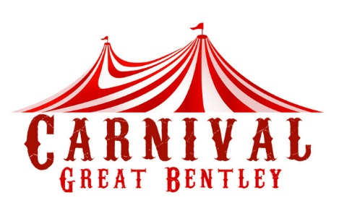
Great Bentley Carnival & Fete Association

Procession Entry Form

Saturday 29th June 2024
Theme for 2024
‘Story Books’

Name/Organisation

Address

Post Code

Telephone

Class of Entry
*Please refer to categories attached or contact us to request details.

Float Theme

Type of Vehicle/Walking

Will entry have Music?

Any special requests

N.B. Carnival Courts only
Please indicate number of people in your court and any special diets

General Data Protection Regulation
Your data will not be shared with any other third parties (unless specifically agreed by yourselves) and the principles of Data Protection Act 2018 and General Data Protection Regulation will be adhered to. (More information can be found at ico.org.uk)

I/We understand that by signing this form I am consenting to Great Bentley Carnival and Fete Association using my submitted data in accordance with GDPR, which will be sending/receiving correspondence from Great Bentley Carnival and Fete Association by post, email, online or by telephone. This consent includes the inclusion of your personal and/or Company details in our contact database
You may withdraw your consent at any time by contacting Great Bentley Carnival and Fete Association in writing by email or post.

PRINT NAME:
ORGANISATION:
SIGNIATURE: |  | Date:

Please return this form no later than 30 May to:
email: bev.k.adams@btinternet.com

