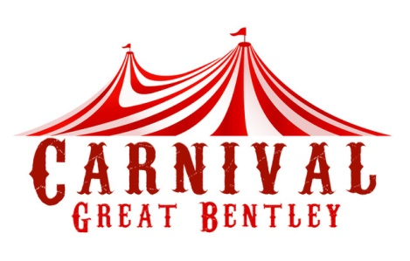
2026

We would like to invite you to take part in our Carnival Procession which is to be held on Saturday 27th June 2026. The theme is Countries

Entries to be received by 20th June please.

This year the competitive classes where a trophy for first place is awarded along with rosettes are as below: -

- Best Visiting Carnival Court Float
- Queen/King of Carnival Court
- Decorated float/vehicle (with/without walkers who will be judged separately see below)
- Children’s Junior Walking Groups (i.e. Cubs, Beavers, Brownies & Rainbows)
- Children’s/Youth Senior Walking Groups (i.e. Guides, Scouts & Explorers)
- Fancy Dress – any age or numbers in entry
- Majorettes
- Visiting schools/floats/groups

There are also awards and rosettes for:-

- Best overall entry in any category
- The Liz Fryer-Kelsey Memorial trophy for the best entry by a registered charity

All entrants to report to the Plough Business centre, Plough Road, Great Bentley (adjacent to the railway station). Please note the following:

- Arrivals from 11.30 am at the assembly area would be appreciated, ready for judging at 11. 45pm and start at 12.30 pm.
- Late arrivals may not be judged.
- Please return entry forms by 20th June 2026
- INSURANCE – Please ensure your float and passengers are insured for entering the Carnival Procession. The Great Bentley Carnival and Fete Committee cannot accept liability for any accidents that may occur to your float and/or passengers.
- No alcohol on floats.
- The committee reserve the right to re-classify entries upon arrival at the assembly point.

Please return entry forms by 20th June to:
Email: bev.k.adams@btinternet.com

